СРО
Вариант 4
Схема что дано:
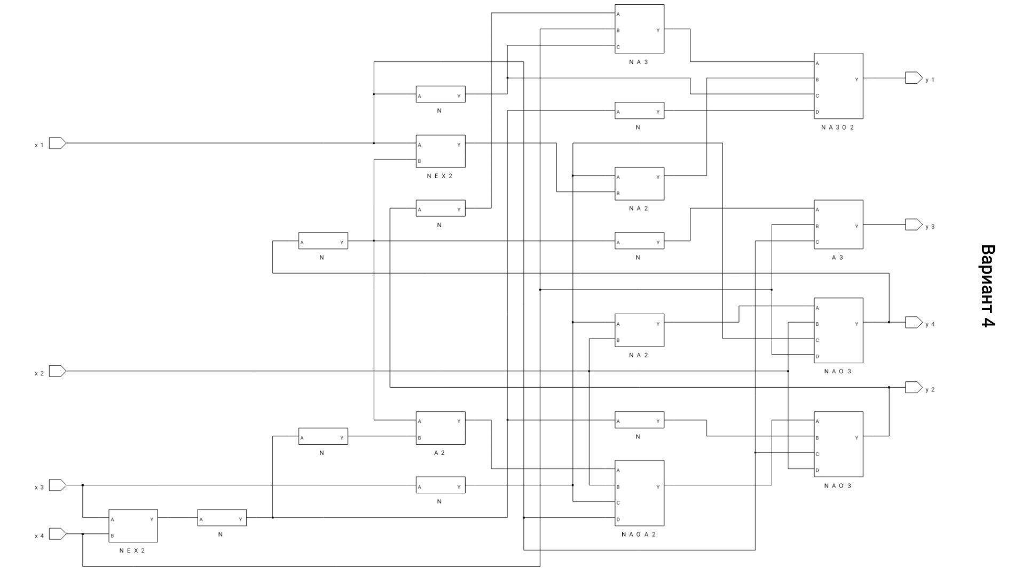
Схема что сделано:
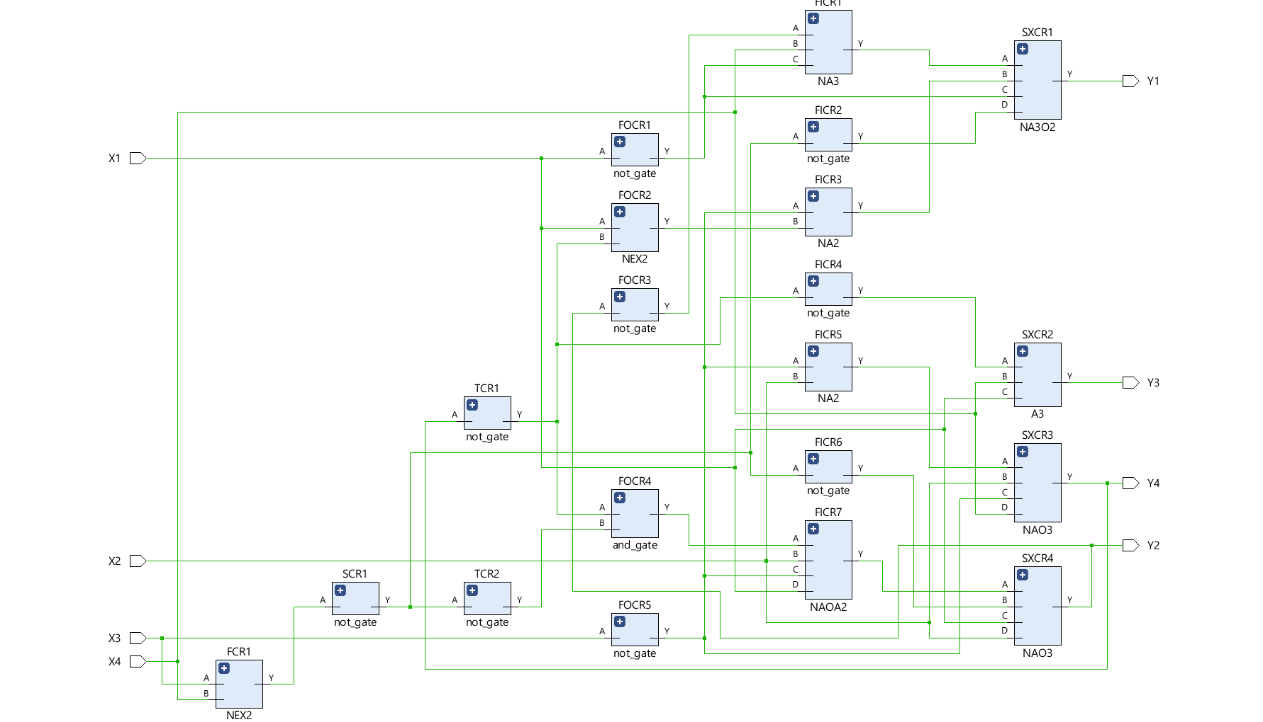
Система логических функций:
y1 = NA3O2
y2 = NAO3
y3 = A3
y4 = NAO3

x1 | x2 | x3 | x4 | y1 | y2 | y3 | y4
0 | 0 | 0 | 0 | 0 | 0 | 0 | 0
0 | 0 | 0 | 1 | 0 | 0 | 0 | 1
0 | 0 | 1 | 0 | 0 | 0 | 0 | 0
0 | 0 | 1 | 1 | 0 | 1 | 1 | 1
0 | 1 | 0 | 0 | 0 | 0 | 0 | 0
0 | 1 | 0 | 1 | 0 | 0 | 0 | 0
0 | 1 | 1 | 0 | 0 | 0 | 0 | 0
0 | 1 | 1 | 1 | 0 | 1 | 1 | 0
1 | 0 | 0 | 0 | 1 | 0 | 0 | 0
1 | 0 | 0 | 1 | 1 | 0 | 0 | 1
1 | 0 | 1 | 0 | 1 | 0 | 0 | 0
1 | 0 | 1 | 1 | 1 | 1 | 1 | 1
1 | 1 | 0 | 0 | 0 | 0 | 0 | 0
1 | 1 | 0 | 1 | 0 | 0 | 0 | 0
1 | 1 | 1 | 0 | 0 | 0 | 0 | 0
1 | 1 | 1 | 1 | 0 | 1 | 1 | 0

